Rumus-rumus berikut boleh membantu anda menjawab soalan. Simbol-simbol yang diberi adalah yang biasa digunakan.

 | DAYA DAN GERAKAN I  FORCE AND MOTION I |  |  | 13 |  | $$Jejari Bumi, R=6.37×{10}^{6} m$$  $$Radius of Earth$$
1 | $$v=u+at$$ |  |  |  |  | HABA  HEAT
2 | $$s=\frac{1}{2}\left(u+v\right)t$$ |  |  | 1 |  | $$Q=mcθ$$
3 | $$s=ut+\frac{1}{2}at^{2}$$ |  |  | 2 |  | $$Q=ml$$
4 | $$v^{2}=u^{2}+2as$$ |  |  | 3 |  | $$Q=Pt$$
5 | Momentum = $mv$ |  |  | 4 |  | $$P_{1}V_{1}=P_{1}V_{1}$$
6 | $$F=ma$$ |  |  | 5 |  | $$\frac{V_{1}}{T_{1}}=\frac{V_{2}}{T_{2}}$$
 | KEGRAVITIAN  GRAVITATION |  |  | 6 |  | $$\frac{P_{1}}{T_{1}}=\frac{P_{2}}{T_{2}}$$
1 | $$F=\frac{{Gm}_{1}m_{2}}{r^{2}}$$ |  |  |  |  | GELOMBANG  WAVES
2 | $$g=\frac{GM}{r^{2}}$$ |  |  | 1 |  | $$v=fλ$$
3 | $$F= \frac{mv^{2}}{r}$$ |  |  | 2 |  | $$λ=\frac{ax}{D}$$
4 | $$a= \frac{v^{2}}{r}$$ |  |  |  |  | CAHAYA DAN OPTIK  LIGHT AND OPTICS
5 | $$v= \frac{2πr}{T}$$ |  |  | 1 |  | $$n=\frac{c}{v}$$
6 | $$\frac{T_{1}^{ 2}}{{r_{1}}^{3}}= \frac{T_{2}^{ 2}}{{r_{2}}^{3}}$$ |  |  | 2 |  | $$n=\frac{\sin{i}}{\sin{r}}$$
7 | $$v=\sqrt{\frac{GM}{r}}$$ |  |  | 3 |  | $$n=\frac{1}{\sin{c}}$$
8 | $$u= -\frac{GMm}{r}$$ |  |  | 4 |  | $$n=\frac{H}{h}$$
9 | $$v=\sqrt{\frac{2GM}{r}}$$ |  |  | 5 |  | $$\frac{1}{f}=\frac{1}{u}+\frac{1}{v}$$
10 | $$g=9.81 m{ s}^{-2}@ 9.81 {N kg}^{-1}$$ |  |  | 6 |  | $$n_{1}{sinθ}_{1}=n_{2}{sinθ}_{2}$$
11 | $$G=6.67×{10}^{-11}{N m}^{2}{kg}^{-2}$$ |  |  | 7 |  | $$Pembesaran linear, m=\frac{v}{u}$$  $$Linear magnification,$$
12 | $$Jisim Bumi, M=5.97×{10}^{24} kg$$  $$Mass of Earth$$
 | DAYA DAN GERAKAN II  FORCE AND MOTION II |  |  |  |  |  | ELEKTRONIK  ELECTRONICS
1 | $$F=kx$$ | 3 | $$E=\frac{1}{2}kx^{2}$$ |  | 1 |  | $$Tenaga keupayaan elektrik, E=eV$$  $$Electrical potential energy$$
2 | $$E=\frac{1}{2}Fx$$ |  |  |  | 2 |  | $$Tenaga kinetik maksimum, E=\frac{1}{2}mv^{2}$$  $$Maximum kinetic energy$$
 | TEKANAN  PRESSURE |  |  |  | 3 |  | $$β=\frac{I_{C}}{I_{B}}$$
1 | $$P=\frac{F}{A}$$ |  |  |  | 4 |  | $$V_{out}=\frac{R_{2}}{R_{1}+R_{2}}V_{in}$$
2 | $$P=hρg$$ |  |  |  |  |  | FIZIK NUKLEAR  NUCLEAR PHYSICS
3 | $$ρ=\frac{m}{V}$$ |  |  |  | 1 |  | $$N={\left(\frac{1}{2}\right)}^{n}N_{o}$$
 | ELEKTRIK  ELECTRICITY |  |  |  | 2 |  | $$E=mc^{2}$$
1 | $$E=\frac{F}{Q}$$ | 6 | $$ℇ=V+Ir$$ |  | 3 |  | $$c=3.00×{10}^{8} m s^{-1}$$
2 | $$I=\frac{Q}{t}$$ | 7 | $$P=VI$$ |  | 4 |  | $$1 u.j.a.=1.66×{10}^{-27} kg$$  $$1 a.m.u.=1.66×{10}^{-27} kg$$
3 | $$V=\frac{E}{Q}$$ | 8 | $$P=\frac{E}{t}$$ |  |  |  | FIZIK KUANTUM  QUANTUM PHYSICS
4 | $$V=IR$$ | 9 | $$E=\frac{V}{d}$$ |  | 1 |  | $$E=hf$$
5 | $$R=\frac{ρl}{A}$$ |  |  |  | 2 |  | $$f=\frac{c}{λ}$$
 | KEELEKTROMAGNETAN  ELECTROMAGNETISM |  |  |  | 3 |  | $$λ=\frac{h}{p}$$
1 | $$\frac{V_{s}}{V_{p}}=\frac{N_{s}}{N_{p}}$$ |  |  |  | 4 |  | $$λ=\frac{h}{mv}$$
2 | $$η=\frac{Kuasa output}{Kuasa input}×100\%$$ |  |  |  | 5 |  | $$E=\frac{hc}{λ}$$
 | $$η=\frac{Output power}{Input power}×100\%$$ |  |  |  | 6 |  | $$P=nhf$$
 |  |  |  |  | 7 |  | $$hf=W+\frac{1}{2}{{mv}^{2}}_{maks}$$
 |  |  |  |  | 8 |  | $$W=hf_{o}$$
 |  |  |  |  | 9 |  | $$h=6.63×{10}^{-34}J s$$

1 | Antara berikut, yang manakah unit bagi kuantiti terbitan?  Which of the following is the unit for a derived quantity?
 | A | Watt, W
 | B | Meter, m
 | C | Ampere, A
 | D | Kilogram, kg
2 | Maklumat di bawah menunjukkan laju dan arah sebuah kapal terbang.  The information below shows the speed and the direction of an aeroplane.  Sebuah kapal terbang bergerak dengan  laju seragam 600 km j⁻¹ ke arah Barat.  An aeroplane moves at a uniform  speed of 600 km h⁻¹ to the West.  Antara kombinasi kuantiti berikut, yang manakah terdapat dalam pernyataan di atas?  Which of the following combination of quantities are found in the statement above?  P: Kuantiti asas R: Kuantiti skalar  Base quantity Scalar quantity  Q: Kuantiti terbitan S: Kuantiti vektor  Derived quantity Vector quantity
 | A | P, R
 | B | Q, R
 | C | P, S
 | D | Q, S
3 | Rajah 1 menunjukkan graf P melawan V.  Diagram 1 shows a graph of P against V.  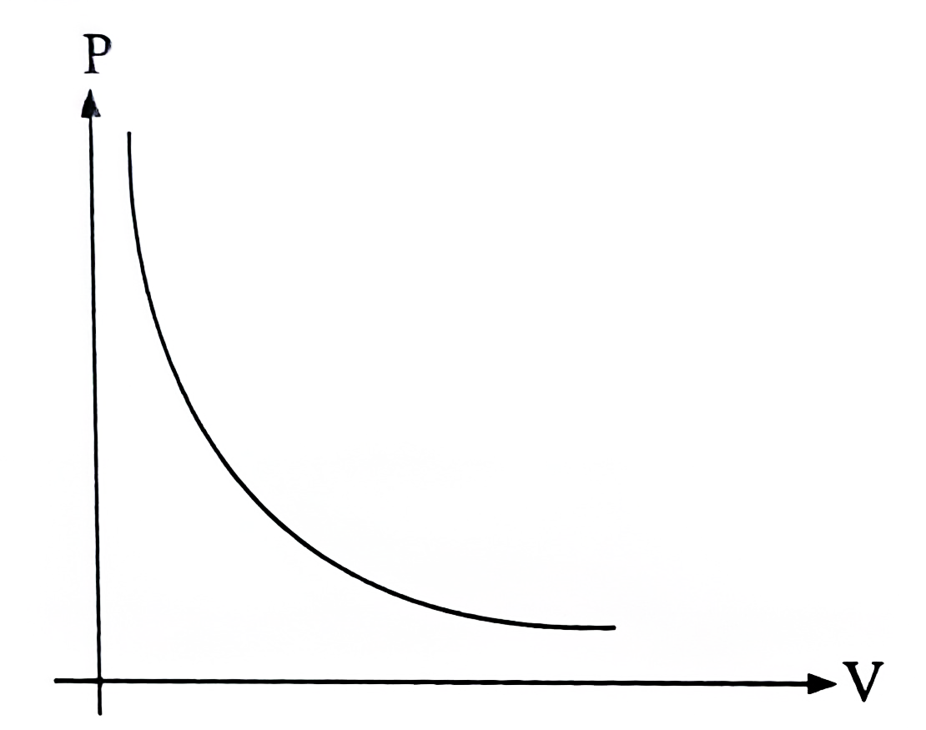  Rajah 1  Diagram 1  Antara berikut, hubungan manakah yang betul?  Which of the following relationship is correct?
 | A |  | P berkurang secara linear dengan V  P decreases linearly with V
 | B |  | V bertambah secara linear dengan P  V increases linearly with P
 | C |  | P berkadar songsang dengan V  P is inversely proportional to V
 | D |  | P berkadar langsung dengan V  P is directly proportional to V
4 | Rajah 2 menunjukkan dua keadaan di sebuah gazebo di halaman rumah Daniel.  Diagram 2 shows two situations at a gazebo in Daniel’s front yard.  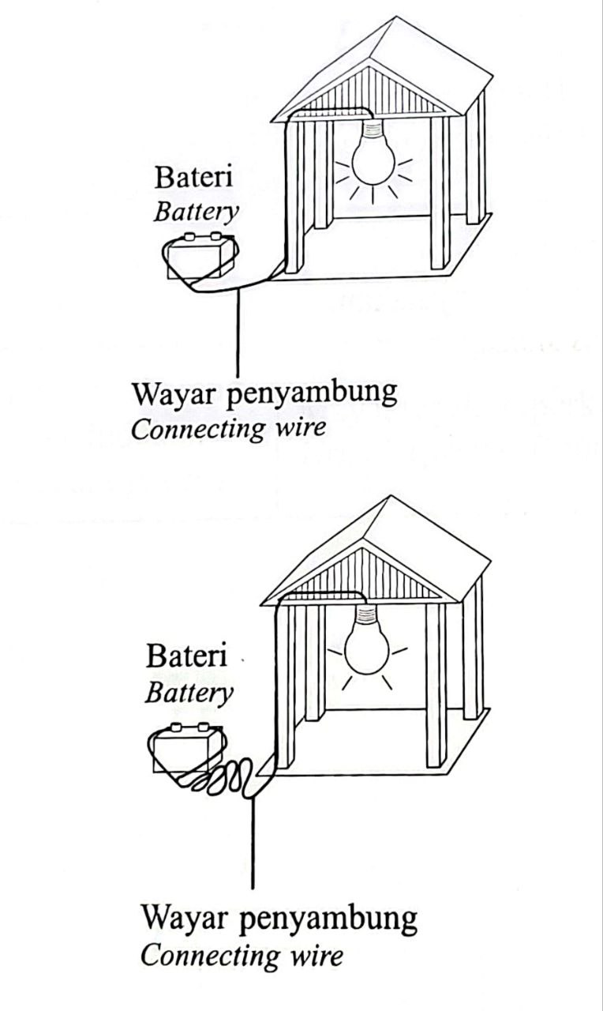  Rajah 2  Diagram 2  Apakah inferens yang bersesuaian berdasarkan pemerhatian anda?  What is the appropriate inference based on your observation?
 | A |  | Panjang wayar penyambung bergantung kepada kecerahan mentol.  The length of the connecting wire depends on the brightness of the bulb.
 | B |  | Kecerahan mentol bergantung kepada panjang wayar penyambung.  The brightness of the bulb depends on the length of the connecting wire.
 | C |  | Semakin bertambah panjang wayar penyambung, semakin berkurang kecerahan mentol.  The longer the length of connecting wire, the lower the brightness of bulb.
 | D |  | Semakin berkurang kecerahan mentol, semakin bertambah panjang wayar penyambung.  The lower the brightness of the bulb, the longer the length of connecting wire.

5 | Rajah 3 menunjukkan laluan larian bagi acara Go Green Fun Run.  Diagram 3 shows a running track for Go Green Fun Run event.  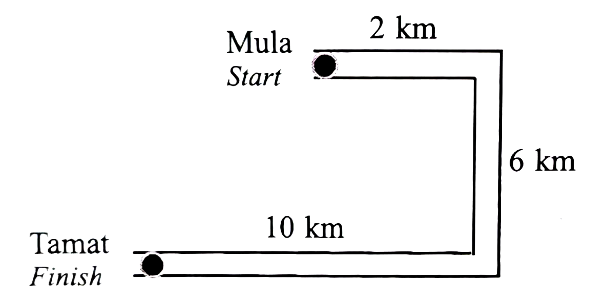  Rajah 3  Diagram 3  Berapakah sesaran bagi seorang peserta larian tersebut?  What is the displacement of a runner of the event?
 | A | 5 km
 | B | 6 km
 | C | 10 km
 | D | 18 km
6 | Rajah 4 menunjukkan graf halaju-masa bagi sebuah kenderaan.  Diagram 4 shows a graph of velocity-time of a vehicle.  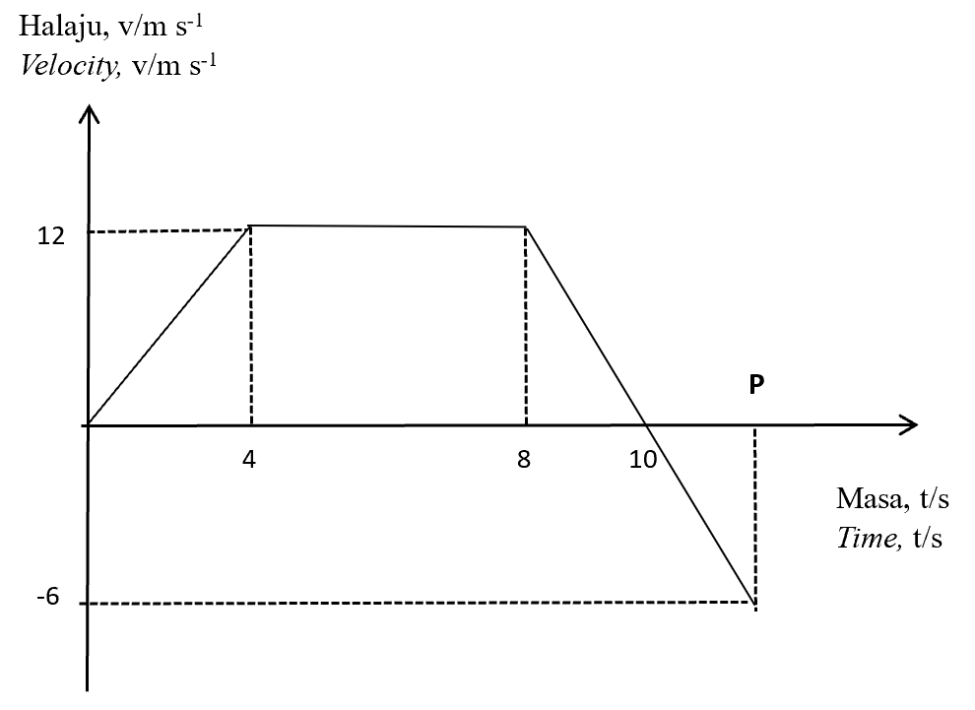  Rajah 4  Diagram 4  Apakah nilai P sekiranya jumlah sesaran kenderaan tersebut adalah 76.80 meter?  What is the value of P if the total displacement of the vehicle is 76.80 meters?
 | A |  | 12.0
 | B |  | 12.4
 | C |  | 13.0
 | D |  | 13.2
7 | Antara yang berikut, graf yang manakah mewakili objek bergerak dengan halaju seragam?  Which of the following graphs represents an object moving with uniform velocity?
 | A |  | 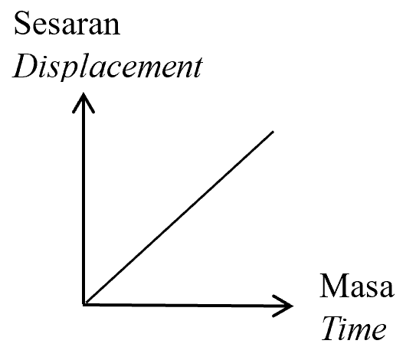
 | B |  | 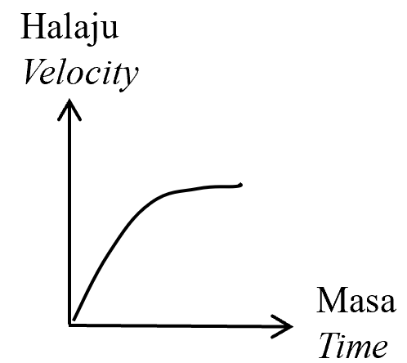
 | C |  | 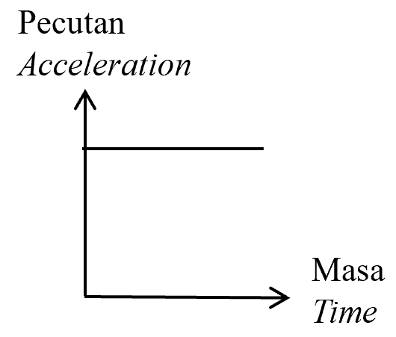
 | D |  | 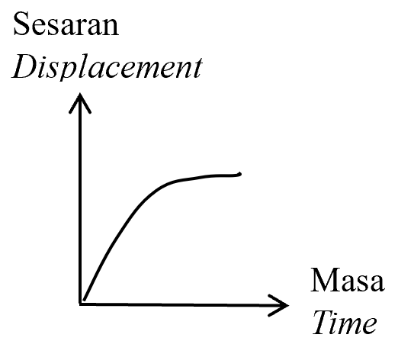

8 | Rajah 5 menunjukkan dua troli. Troli P mempunyai isipadu yang lebih besar daripada troli Q. Kedua-dua troli mempunyai jisim yang sama dan bergerak pada arah yang berlawanan dengan halaju yang sama.  Diagram 5 shows two trolleys. Trolley P has a larger volume than trolley Q. Both trolleys have the same mass and move in opposite directions with the same velocity.  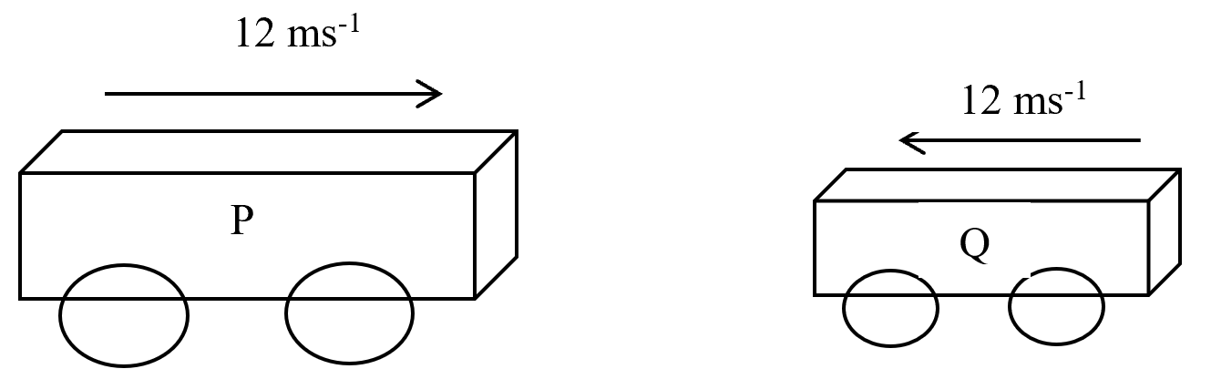  Rajah 5  Diagram 5  Antara yang berikut, pernyataan manakah adalah benar?  Which of the following statements is true?
 | A |  |  | Momentum troli Q adalah sifar.  The momentum of trolley Q is zero.
 | B |  |  | Momentum troli P adalah lebih besar daripada momentum troli Q.  The momentum of trolley P is greater than the momentum of trolley Q.
 | C |  |  | Momentum kedua-dua troli adalah sifar kerana bergerak pada arah yang bertentangan.  The momentum of both trolleys is zero because they are moving in opposite directions.
 | D |  |  | Momentum kedua-dua troli adalah sama magnitud tetapi berlainan arah.  The momentum of both trolleys is the same magnitude but in different directions.
9 | Antara yang berikut, pasangan manakah yang mempunyai inersia paling besar?  Which of the following pair has the greatest inertia?
 | Halaju / m s⁻¹  Velocity / m s⁻¹ | Jisim / kg  Mass / kg
A | 164.5 | 1.3
B | 143.7 | 12.5
C | 15.2 | 24.6
D | 20.1 | 14.7

10 | Rajah 6 menunjukkan dua troli yang sama, R dan S bergerak ke arah satu sama lain masing-masing dengan halaju 4 m s⁻¹ dan 6 m s⁻¹.  Diagram 6 shows two identical trolleys, R and S moving towards each other with velocity 4 m s⁻¹ and 6 m s⁻¹ respectively.  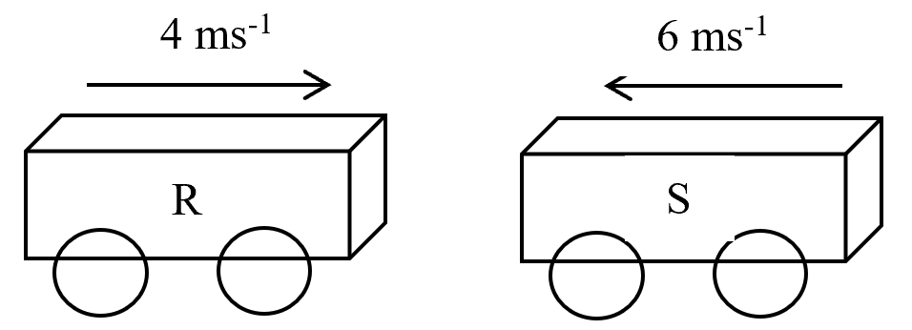  Rajah 6  Diagram 6  Antara yang berikut, yang manakah menerangkan perlanggaran tersebut?  Which of the following explains the collision?
 | A |  |  | Tenaga kinetik diabadikan.  Kinetic energy is conserved.
 | B |  |  | Berlaku kehilangan tenaga.  There is a loss of energy.
 | C |  |  | Selepas perlanggaran, kedua-dua troli akan melekat bersama dan bergerak.  After collision, the trolleys will stick together and move.
 | D |  |  | Jumlah momentum akhir adalah kurang daripada jumlah momentum awal.  Final total momentum is less than initial total momentum.
11 | Antara bongkah kayu berikut, yang manakah akan mengalami pecutan terkecil apabila  dikenakan daya, F yang sama?  Which of the following wooden block will experience the smallest acceleration when the same force, F is applied?
 | A | 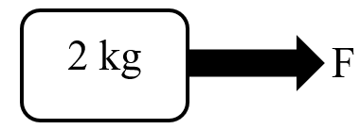
 | B | 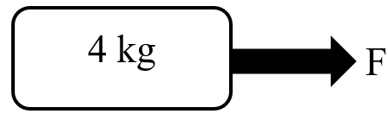
 | C | 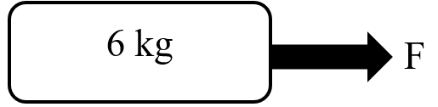
 | D | 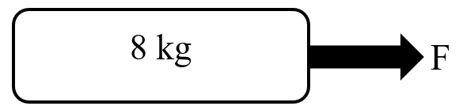
12 | Rajah 7 menunjukkan seorang pemain kriket memukul bola pegun yang berjisim  0.15 kg. Bola itu bergerak ke hadapan dengan halaju 60 m s⁻¹ dan masa perlanggaran antara kayu pemukul pemain dengan bola ialah 5 ms.  Diagram 7 shows a cricket player hits a stationary ball of mass 0.15 kg. The ball moves forward with a velocity 60 m s⁻¹ and the time of impact between the player’s bat and the ball is 5 ms.  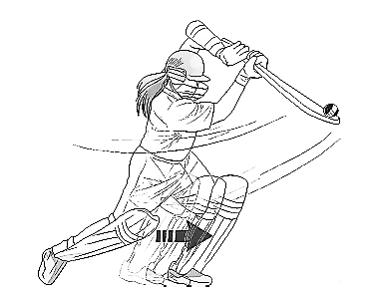  Rajah 7  Diagram 7  Berapakah daya impuls bola kriket itu?  What is the impulsive force of the cricket ball?
 | A | 1.8 N
 | B | 18 N
 | C | 180 N
 | D | 1800 N
13 | Rajah 8 menunjukkan daya graviti, F yang bertindak ke atas dua jasad berjisim m₁ dan m₂.  Diagram 8 shows a gravitational force, F acting on two bodies with mass m₁ and m₂ respectively.  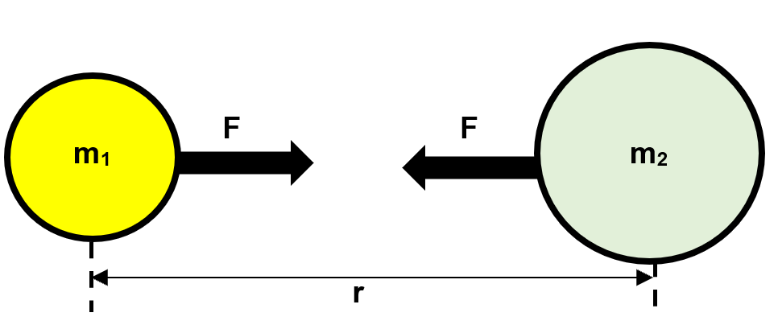  Rajah 8  Diagram 8  Antara berikut yang manakah menerangkan hubungan antara F, m₁, m₂ dan r?  Which of the following explains the relationship between F, m₁, m₂ and r?
 | F dengan m₁ dan m₂  F with m₁ dan m₂ | F dengan r  F with r
A | $$F α m_{1}m_{2}$$ | $$Fα r^{2}$$
B | $$Fα\frac{1}{m_{1}m_{2}}$$ | $$Fα r^{2}$$
C | $$F α m_{1}m_{2}$$ | $$F α \frac{1}{r^{2}}$$
D | $$Fα\frac{1}{m_{1}m_{2}}$$ | $$F α \frac{1}{r^{2}}$$

14 | Rajah 9 menunjukkan sebuah satelit berada pada ketinggian, h m dari permukaan Bumi mengalami pecutan graviti, g, 8.95 m s⁻².  [Pemalar kegravitian, G = 6.67 × 10⁻¹¹ N m² kg⁻²]  [Jisim Bumi, M = 5.97 × 10²⁴ kg]  [Jejari Bumi, R = 6.37 × 10⁶ m]  Diagram 9 shows a satellite is at a height, h m above the Earth's surface experiences gravitational acceleration, g, 8.95 m s⁻².  [Gravitational constant, G = 6.67 × 10⁻¹¹ N m² kg⁻²]  [Mass of the Earth, M = 5.97 × 10²⁴ kg]  [Radius of the Earth, R = 6.37 × 10⁶ m]  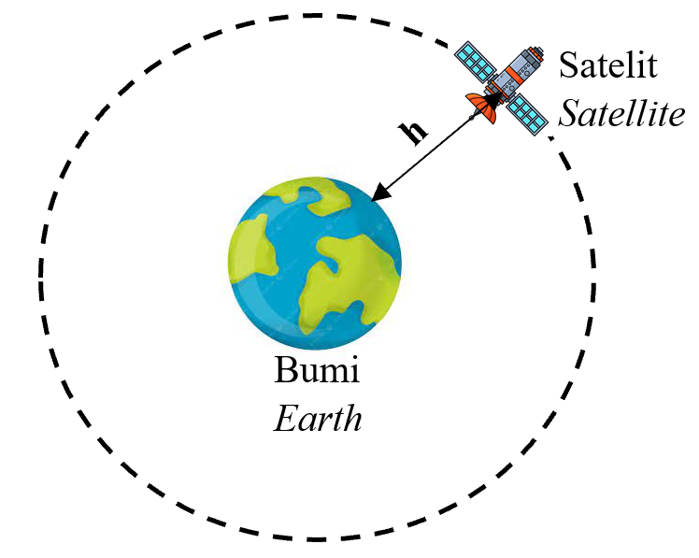  Rajah 9  Diagram 9  Apakah ketinggian, h?  What is height, h?
 | A |  | 3.0 x 10⁵ m
 | B |  | 4.8 x 10⁵ m
 | C |  | 1.2 x 10⁶ m
 | D |  | 6.7 x 10⁶ m

15 | Berikut ialah perbualan antara guru dan murid semasa kelas Fizik.  Murid: Mengapakah Bulan mengambil masa yang lebih singkat untuk mengorbit Bumi berbanding mengorbit Matahari?  Guru: Hal ini demikian kerana jejari orbit Bulan lebih kecil daripada jejari orbit Bumi. Semakin besar jejari orbit, semakin panjang tempoh orbit.  The following is a conservation between a teacher and student during Physics class.  Student: Why does the Moon take shorter time to orbit the Earth than the Earth orbits the Sun?  Teacher: It is because the radius of orbit of the Moon is smaller than the radius of orbit of the Earth. The larger the radius of an orbit, the longer the orbital period.  Perbualan antara guru dan murid dapat menyimpulkan satu hukum Fizik iaitu  The conversation between teacher and student can conclude a Physics law which is
 | A |  | Hukum Kepler Pertama  Kepler’s First Law
 | B |  | Hukum Kepler Kedua  Kepler’s Second Law
 | C |  | Hukum Kepler Ketiga  Kepler’s Third Law
 | D |  | Hukum Kegravitian Semesta Newton  Newton’s Universal Law of Gravitation
16 | Rajah 10 menunjukkan Planet X dan Planet Y yang sedang mengorbit Matahari.  Diagram 10 shows Planet X and Planet Y orbiting the Sun.  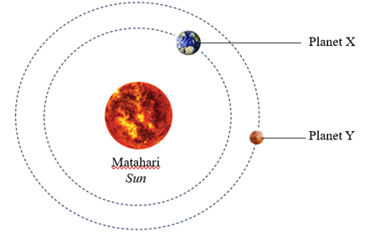  Rajah 10  Diagram 10  Berdasarkan Hukum Kepler Ketiga, bandingkan nisbah kuasa dua tempoh orbit dengan kuasa tiga jejari orbit kedua-dua planet tersebut.  Based on Kepler’s Third Law, compare the ratio of the square of the orbital period to the cube of the orbital radius of the two planets.
 | A | Kedua-dua planet mempunyai nilai $\frac{T^{2}}{r^{3}}$ yang sama.  Both planets have the same value of $\frac{T^{2}}{r^{3}}$.
 | B | Planet X mempunyai nilai $\frac{T^{2}}{r^{3}}$ lebih besar daripada Planet Y.  Planet X has a greater value of $\frac{T^{2}}{r^{3}}$ than Planet Y.
 | C | Planet Y mempunyai nilai $\frac{T^{2}}{r^{3}}$ lebih besar daripada Planet X.  Planet Y has a greater value of $\frac{T^{2}}{r^{3}}$ than Planet X.
17 | Satelit A sentiasa berada di atas kedudukan geografi yang sama di permukaan bumi.  Satellite A is always above the same geographical location.  Berdasarkan pernyataan di atas, yang manakah antara berikut merupakan satelit A?  Based on the statement above, which of the following is Satellite A?
 | A | TiungSAT
 | B | RazakSAT
 | C | MEASAT
 | D | GPS
18 | Rajah 11 menunjukkan sebuah satelit komunikasi sedang mengorbit Bumi pada ketinggian, h = 36 000 km dari permukaan Bumi.  Diagram 11 shows a communication satellite orbiting the Earth at an altitude of  h = 36 000 km from the Earth's surface.  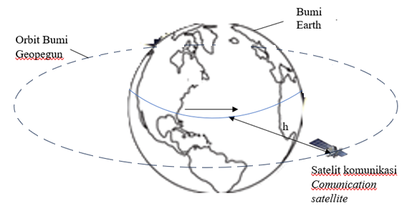  Rajah 11  Diagram 11  Mengapakah Orbit Bumi Geopegun sesuai untuk digunakan oleh satelit komunikasi?  Why is Geostationary Orbit of Earth is suitable to be used for communication satellites?
 | A |  | Satelit tidak bergerak berbanding permukaan Bumi, memudahkan antena penerima bumi.  Satellites are stationary relative to the Earth's surface, making it easier for ground-based receiving antennas.
 | B |  | Satelit bergerak lebih laju daripada putaran Bumi, memberi liputan global.  Satellites move faster than the Earth's rotation, providing global coverage.
 | C |  | Satelit mengelilingi Bumi dari kutub ke kutub, memantau cuaca global.  Satellites circle the Earth from pole to pole, monitoring global weather.
 | D |  | Satelit dapat dikesan dengan mudah oleh teleskop optik di Bumi.  Satellites can be easily detected by optical telescopes on Earth.

19 | Rajah 12 menunjukkan air kopi yang panas dalam sebiji cawan tanah liat yang sejuk. Selepas beberapa ketika, didapati suhu air kopi dan cawan tanah liat menjadi sama.  Diagram 12 shows hot coffee in a cool clay cup. After a while, it is found that the temperature of the hot coffee and the clay cup become the same.  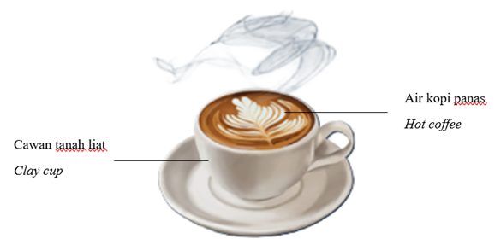  Rajah 12  Diagram 12  Antara berikut, pernyataan manakah yang betul tentang situasi di atas?  Which of the following statements is correct about the situation above?
 | A |  | Terdapat pemindahan bersih haba di antara air kopi panas dan cawan tanah liat.  There is net heat transfer between the hot coffee and the clay cup.
 | B |  | Pemindahan bersih haba antara air kopi panas dan cawan tanah liat menjadi sifar.  The net heat transfer between the hot coffee and the clay cup becomes zero.
 | C |  | Kadar pemindahan haba dari cawan tanah liat ke air kopi panas lebih tinggi daripada kadar pemindahan haba dari air kopi ke cawan tanah liat.  The rate of heat transfer from the clay cup to the hot coffee is higher than the rate of heat transfer from hot coffee to the clay cup.
 | D |  | Kadar pemindahan haba dari air kopi panas ke cawan tanah liat lebih tinggi daripada kadar pemindahan haba dari cawan tanah liat ke air kopi panas.  The rate of heat transfer from the hot coffee to the clay cup is higher than the rate of heat transfer from the clay cup to the hot coffee.
20 | Pada waktu malam, didapati air laut lebih panas berbanding dengan pasir di kawasan daratan. Antara berikut, pernyataan manakah yang benar tentang fenomena ini?  At night, it is found that the sea water is hotter compared to the sand on land. Which of the following statements is true about this phenomenon?
 | A |  | Laut mempunyai muatan haba yang lebih rendah daripada daratan.  The sea has a lower heat capacity than land.
 | B |  | Laut mempunyai muatan haba tentu yang lebih tinggi daripada daratan.  The sea has a higher specific heat capacity than land.
 | C |  | Laut mempunyai muatan haba tentu yang lebih rendah daripada daratan.  The sea has a lower specific heat capacity than land.
 | D |  | Laut mempunyai haba pendam tentu yang lebih rendah daripada daratan.  The sea has a lower specific latent heat than land.
21 | 17 600 J haba digunakan untuk meningkatkan suhu sebuah blok logam 800 g daripada 30°C kepada 55°C.  Berapakah muatan haba tentu blok logam itu?  17 600 J of heat is used to increase the temperature of 800 g metal block from 30°C to 55°C.  What is the specific heat capacity of the metal block?
 | A | 259 J kg^{–1} °C^{–1}
 | B | 400 J kg^{–1} °C^{–1}
 | C | 733 J kg^{–1} °C^{–1}
 | D | 880 J kg^{–1} °C^{–1}
22 | Rajah 13 menunjukkan proses ais bertukar kepada air.  Diagram 13 shows a process of ice changes to water.  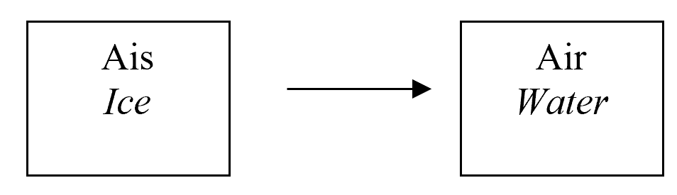  Rajah 13  Diagram 13  Manakah antara haba berikut diserap semasa proses ini?  Which of the following heat is absorbed during the process?
 | A | muatan tentu haba  specific heat capacity
 | B | haba pendam pelakuran  latent heat of fusion
 | C | haba pendam pengewapan  latent heat of vaporization
 | D | heat capacity  muatan haba

23 | Rajah 14 menunjukkan satu graf yang menunjukkan lengkung pemanasan air.  Diagram 14 shows a graph of the heating curve of water.
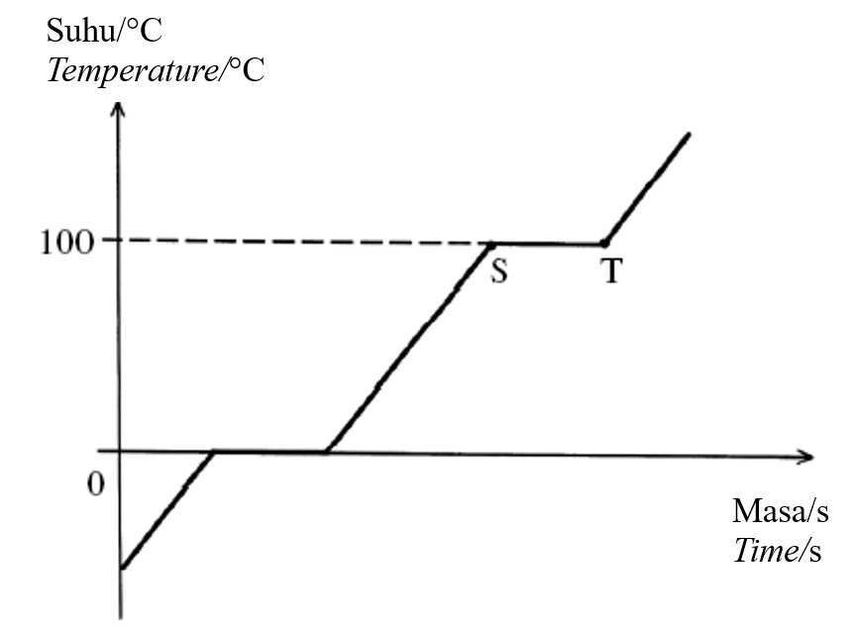
Rajah 14
Diagram 14

Apakah kesan haba yang diserap oleh air antara titik S dan titik T?
What is the effect of the heat absorbed by the water between point S and point T?
 | A | Melemahkan daya antara molekul air.  It weakens the forces between the water molecules.
 | B | Memutuskan ikatan antara molekul air.  It breaks the bonds between the water molecules.
 | C | Menambahkan tenaga kinetik molekul air.  It increases the kinetic energy of the water molecules.
 | D | Menguatkan ikatan antara molekul air.  It strengthens the bonds between the water molecules.

24 | Satu eksperimen dijalankan untuk menyiasat perubahan tekanan, P dengan suhu, T bagi suatu gas yang berjisim tetap. Graf yang manakah menunjukkan hubungan antara tekanan dengan suhu yang betul?  An experiment is carried out to investigate the change of pressure, P with temperature, T for a fixed mass of gas. Which graph shows the correct relationship between pressure and temperature?
 | A | 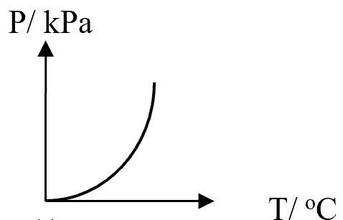
 | B | 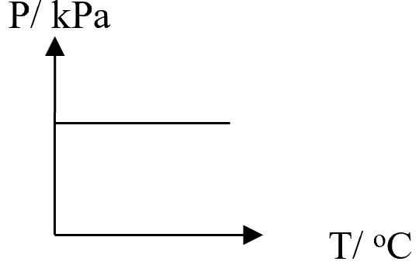
 | C | 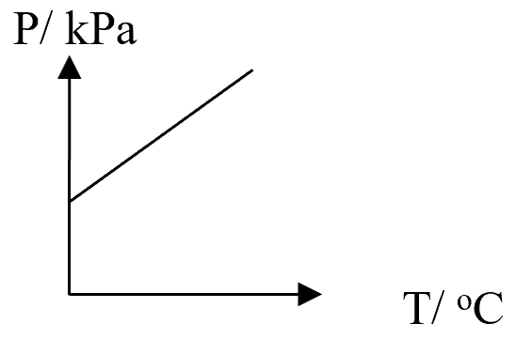
 | D | 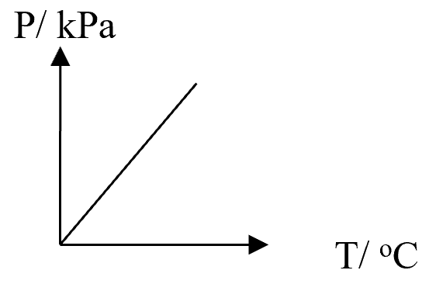
25 | Tekanan udara dalam tayar kereta ialah 200 kPa pada suhu 25 °C.  Berapakah tekanan dalam tayar tersebut pada suhu 37°C?  [Anggap isipadu udara dalam tayar adalah tetap]  The air pressure in a car tyre is 200 kPa at a temperature of 25 °C.  What is the air pressure in the tyre at a temperature of 37 °C?  [Assume the volume of the air in the tyre is constant]
 | A | 135 kPa
 | B | 190 kPa
 | C | 192 kPa
 | D | 208 kPa

26 | Rajah-rajah berikut menunjukkan graf sesaran gelombang air melawan masa.  Gelombang yang manakah mempunyai tenaga yang paling besar?  The following diagrams show the graph of displacement of water waves against time.  Which wave has the greatest energy?
 | A | 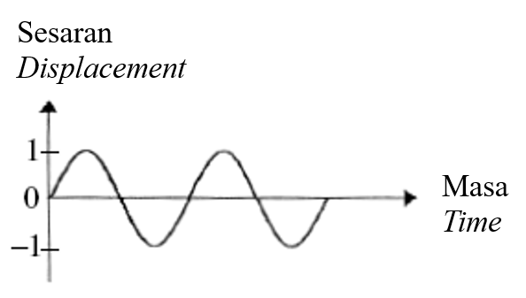
 | B | 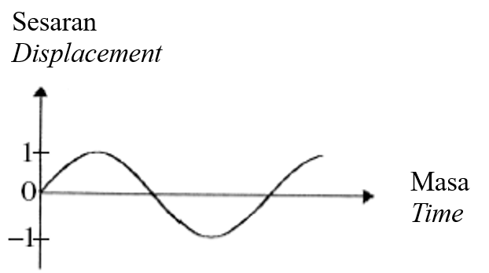
 | C | 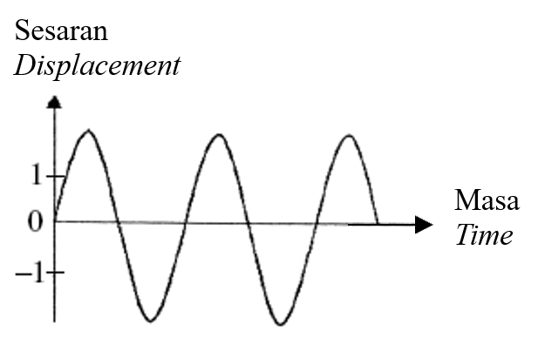
 | D | 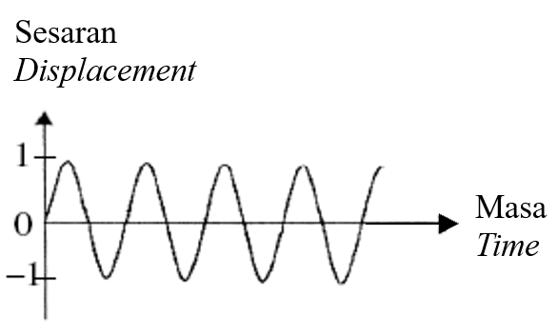

27 | Rajah 15 menunjukkan graf sesaran-masa bagi suatu ayunan spring.  Diagram 15 shows a displacement-time graph of an oscillating spring.
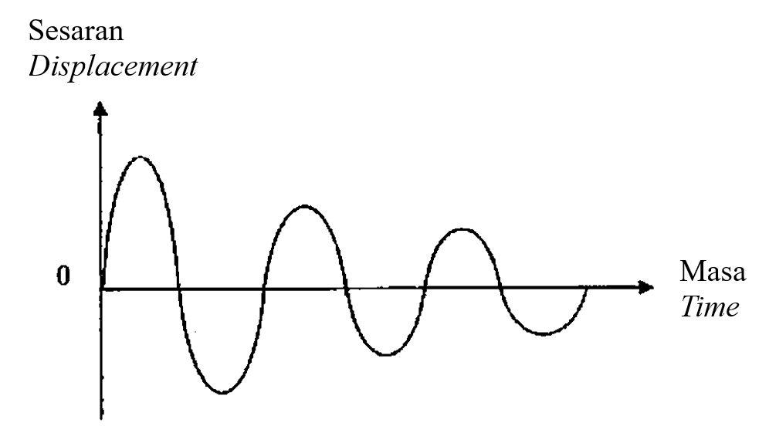
Rajah 15
Diagram 15

Spring itu sedang mengalami
The spring undergoes
 | A | pelembapan  damping
 | B | resonans  resonance
 | C | interferens  interference
 | D | ayunan paksa  forced oscillation
28 | Rajah 16 menunjukkan satu gelombang bunyi dipantulkan daripada dinding konkrit.  Diagram 16 shows a sound wave reflected from a concrete wall.  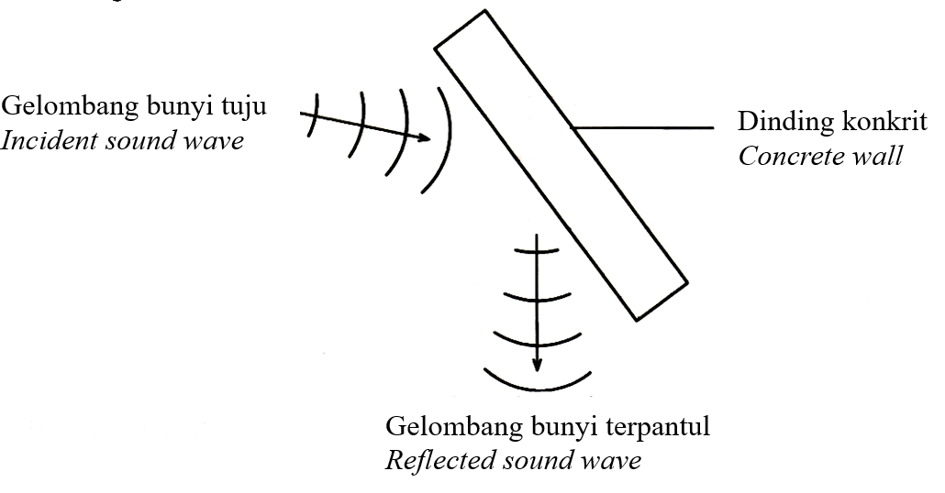  Rajah 16  Diagram 16  Perbandingan manakah yang betul bagi gelombang bunyi terpantul dengan gelombang bunyi tuju?  Which comparison is correct about the reflected sound wave and the incident sound wave?
 | I |  | Laju bagi gelombang tuju adalah sama dengan gelombang terpantul.  The speed of the incident wave is the same as the reflected wave.
 | II |  | Frekuensi gelombang tuju adalah lebih besar daripada gelombang terpantul.  The frequency of the incident wave is greater than the reflected wave.
 | III |  | Panjang gelombang bagi gelombang tuju dan gelombang terpantul adalah sama.  The wavelength of the incident wave and the reflected wave is the same.
 | IV |  | Sudut tuju gelombang tuju adalah lebih kecil daripada sudut pantulan gelombang terpantul.  The angle of incidence of the incident wave is smaller than the angle of reflection of the reflected wave.
 | A |  | I dan II  I and II
 | B |  | II dan IV  II and IV
 | C |  | I dan III  I and III
 | D |  | I, II dan IV  I, II and IV
29 | Sebuah radar memancarkan isyarat ke arah sebuah kapal terbang.  Halaju isyarat itu ialah 3.0 × 10⁸ m s⁻¹.  Selepas 4.0 × 10⁻³ s, radar itu mengesan isyarat yang dipantulkan.  Berapakah jarak kapal terbang itu daripada radar?  A radar transmits a signal towards an aeroplane.  The velocity of the signal is 3.0 × 10⁸ m s⁻¹.  After 4.0 × 10⁻³ s, the radar detects the reflected signal.  What is the distance of the aeroplane from the radar?
 | A |  | 2.4 × 10⁶ m
 | B |  | 1.2 × 10⁶ m
 | C |  | 6.0 × 10⁵ m
 | D |  | 1.5 × 10⁵ m

30 | Raiah 17 menunjukkan suatu gelombang merambat dari kawasan X ke kawasan Y. KL adalah sempadan pemisah antara dua kawasan tersebut.  Diagram 17 shows the waves traveling from region X to region Y. KL is the boundary between the two regions.  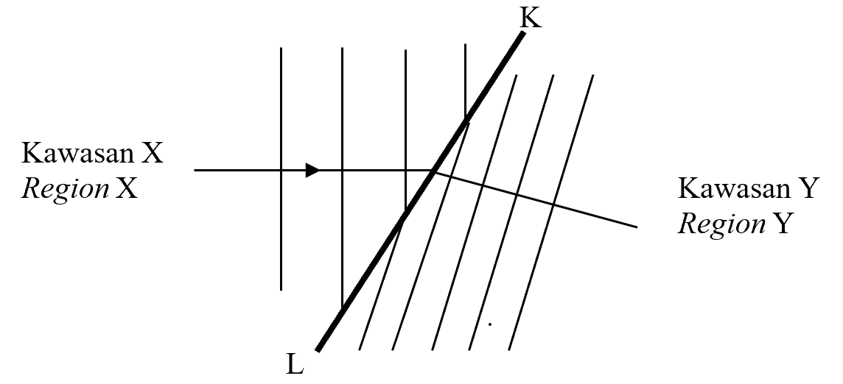  Rajah 17  Diagram 17  Kenyataan yang manakah adalah benar?  Which of the following is true?
 | A |  | Halaju gelombang berkurang.  Velocity of the waves decreases.
 | B |  | Panjang gelombang bertambah.  Wavelength of the waves increases.
 | C |  | Frekuensi gelombang berkurang.  Frequency of the waves decreases.
 | D |  | Kawasan X lebih cetek dari kawasan Y.  Region X is shallower than region Y.
31 | Pilih kuantiti fizik yang tidak berubah apabila suatu gelombang merambat melalui satu celah.  Choose the physical quantities that remain unchanged when a wave propagates through a slit.
 | I |  | Laju  Speed
 | II |  | Amplitud  Amplitude
 | III |  | Frekuensi  Frequency
 | IV |  | Panjang gelombang  Wavelength
 | A |  | I dan II sahaja  I and II only
 | B |  | III dan IV sahaja  III and IV only
 | C |  | II, III dan IV sahaja  II, III and IV only
 | D |  | I, III dan IV sahaja  I, III and IV only
32 | Rajah 18 menunjukkan susunan radas yang digunakan dalam eksperimen interferens bunyi. Bunyi yang kuat berselang seli dengan bunyi yang lemah.  Diagram 18 shows the arrangement of the apparatus used in the sound interference experiment. Loud sounds alternate with weak sounds.  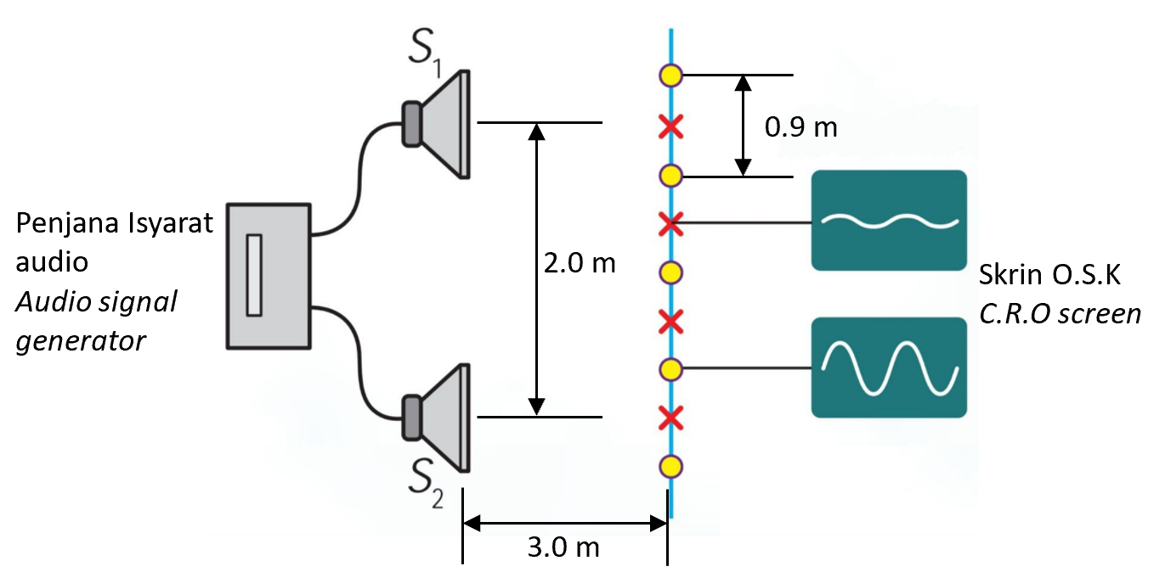  Rajah 18  Diagram 18  Hitung panjang gelombang bagi bunyi yang digunakan dalam eksperimen tersebut.  Calculate the wavelength of the sound used in the experiment.
 | A | 0.6 m
 | B | 1.2 m
 | C | 1.6 m
 | D | 1.8 m
33 | Nyatakan satu ciri gelombang electromagnet.  State one characteristic of electromagnetic waves.
 | A |  | Tidak boleh merambat melalui vakum.  Cannot propagate through vacuum.
 | B |  | Bergerak dengan laju yang lebih tinggi dalam medium.  Move with higher speed in medium.
 | C |  | Tidak memerlukan medium perambatan.  Does not require a propagation medium.
 | D |  | Hanya menunjukkan fenomena pembiasan dan pembelauan sahaja.  Shows the phenomenon of refraction and diffraction only.

34 | Rajah 19 menunjukkan satu sinar cahaya merambat dari udara ke dalam kaca.  Diagram 19 shows a light ray propagating from air into glass.  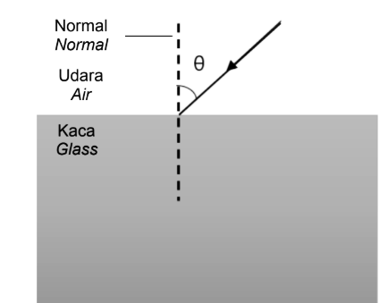  Rajah 19  Diagram 19  Apakah yang akan berlaku kepada sinar cahaya di dalam kaca?  What will happen to the light ray in the glass?
 | A | Dibiaskan mendekati garis normal.  Refracted towards normal.
 | B | Dibiaskan menjauhi garis normal.  Refracted away from normal.
 | C | Mengalami pantulan dalam penuh.  Undergo total internal reflection.
 | D | Halaju cahaya semakin bertambah.  Speed of light increases gradually.
35 | Apakah yang akan berlaku kepada sudut pembiasan jika sudut tuju cahaya yang merambat dari kaca ke udara bertambah?  What will happen to the angle of refraction if the angle of incidence of light propagating from glass to air increases?
 | A | Berkurang  Decreases
 | B | Bertambah  Increases
 | C | Tidak berubah  Unchanged
 | D | Berkurang kemudian bertambah  Decreases then increases
36 | Rajah 20 menunjukkan satu serabut optik.  Diagram 20 shows a fibre optic.  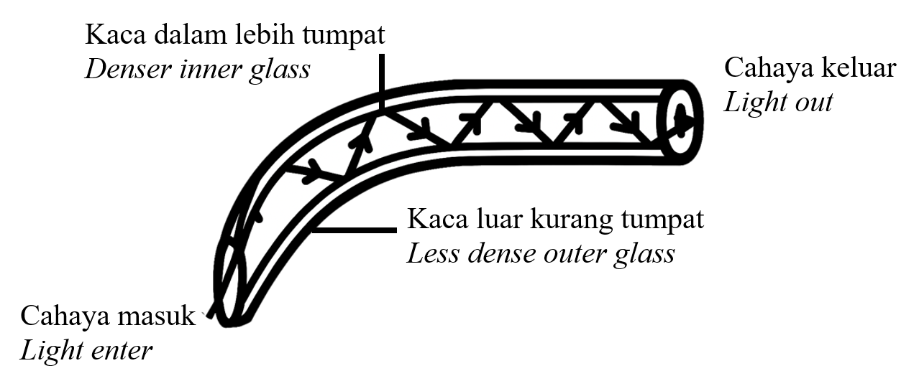  Rajah 20  Diagram 20  Apakah fenomena gelombang yang berlaku?  What is the wave phenomenon occurred?
 | A | Pembiasan cahaya  Refraction of light
 | B | Pembelauan cahaya  Diffraction of light
 | C | Interferens cahaya  Interference of light
 | D | Pantulan dalam penuh  Total internal reflection
37 | Rajah 21 menunjukkan seorang ahli gemologi sedang menggunakan kanta pembesar untuk melihat berlian dengan lebih jelas.  Diagram 21 shows a gemmologist using a magnifying glass to observe the diamond clearly.  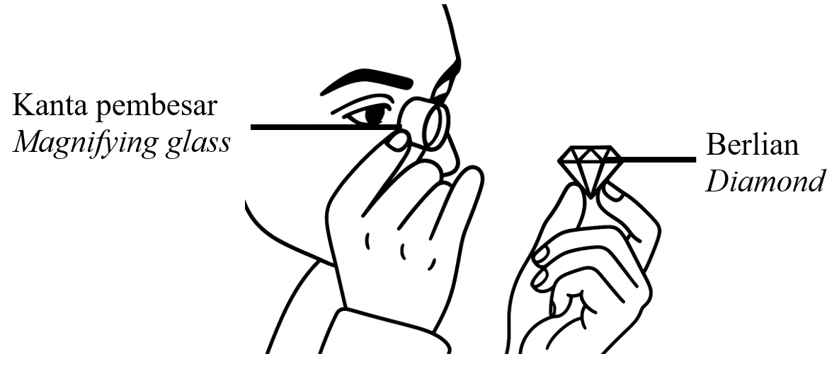  Rajah 21  Diagram 21  Apakah ciri imej berlian yang terbentuk?  What is the characteristic of the image formed by the diamond?
 | A | Mengecil  Diminished
 | B | Songsang  Inverted
 | C | Nyata  Real
 | D | Maya  Virtual
38 | Rajah 22 menunjukkan satu objek yang diletakkan 12 cm dari satu kanta cembung. Panjang fokus kanta itu ialah 8 cm.  Diagram 22 shows an object is placed 12 cm from a convex lens. The focal length of the lens is 8 cm.  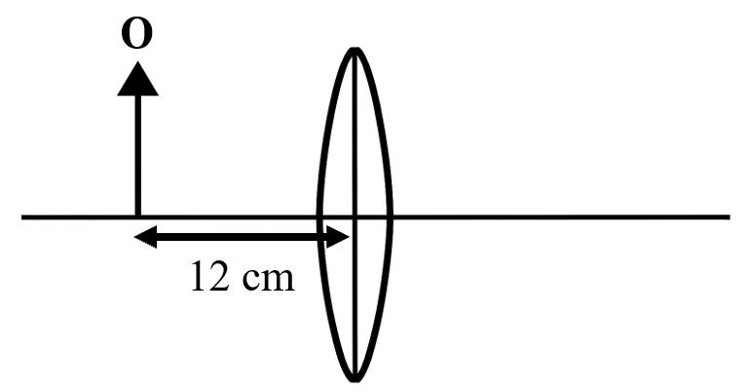  Rajah 22  Diagram 22  Berapakah jarak imej dari kanta itu?  What is the image distance from the lens?
 | A | 4 cm
 | B | 18 cm
 | C | 20 cm
 | D | 24 cm
39 | Rajah 23 menunjukkan satu cermin pergigian yang digunakan oleh doktor gigi untuk memeriksa keadaan gigi pesakit.  Diagram 23 shows a dental mirror used by a dentist to examine the condition of the patient's teeth.  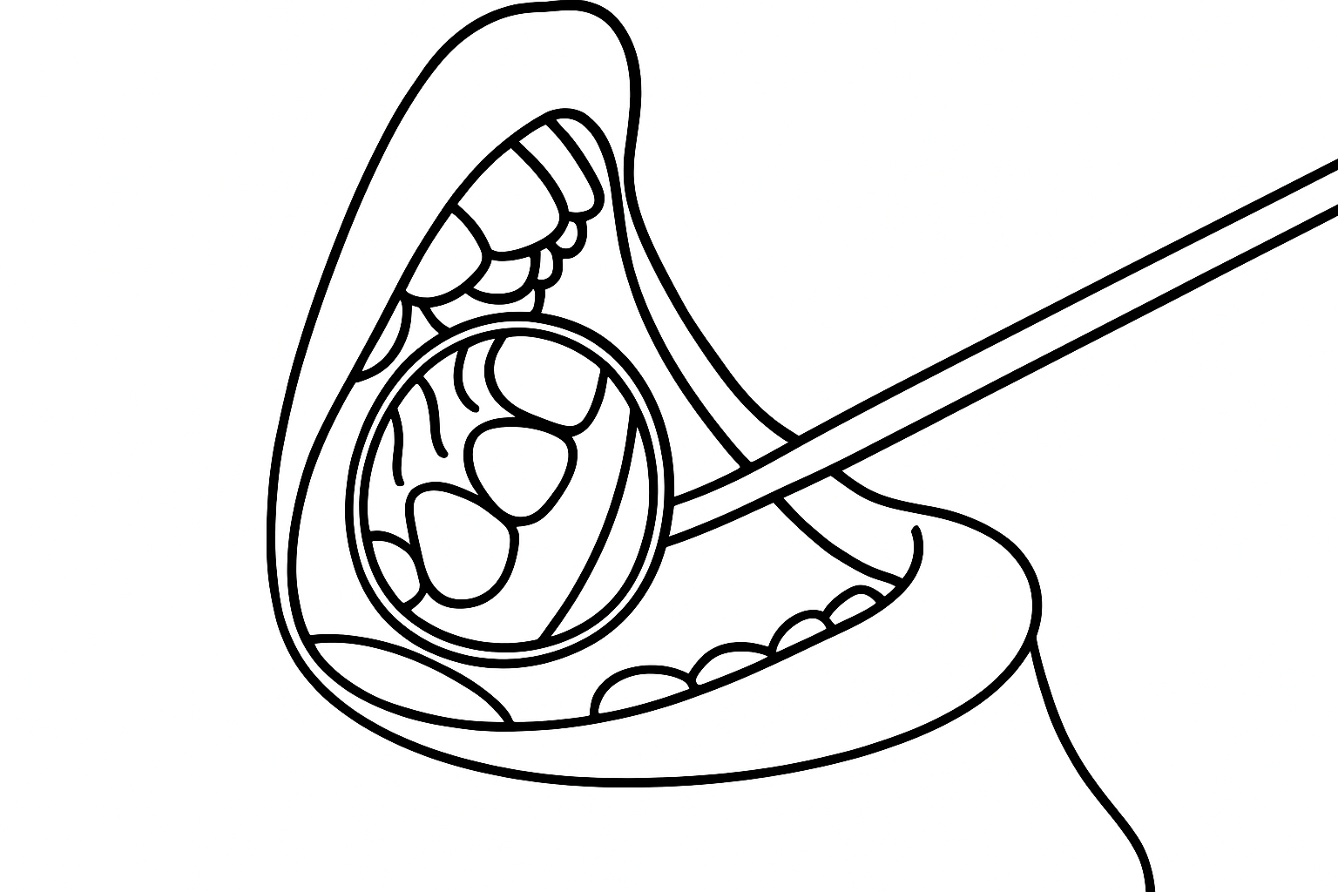  Rajah 23  Diagram 23  Apakah jenis cermin yang digunakan?  What type of mirror is used?
 | A | Cermin satah  Plane mirror
 | B | Cermin sfera  Spherical mirror
 | C | Cermin cembung  Convex mirror
 | D | Cermin cekung  Concave mirror
40 | Rajah manakah yang menunjukkan pantulan cahaya yang betul oleh sebuah cermin cekung?  Which diagram shows the correct reflection of light by a concave mirror?
 | A | 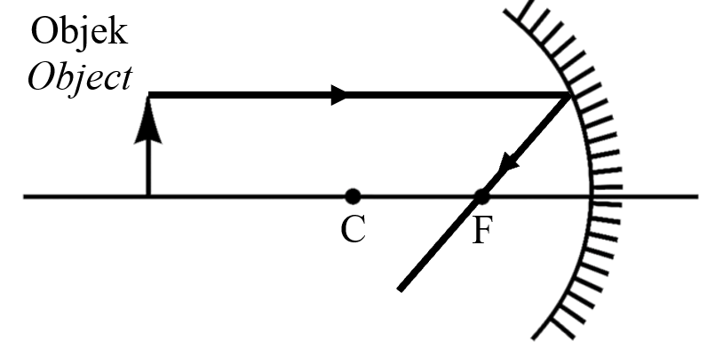
 | B | 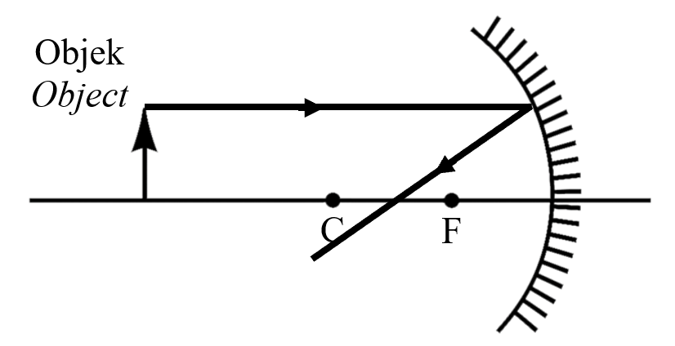
 | C | 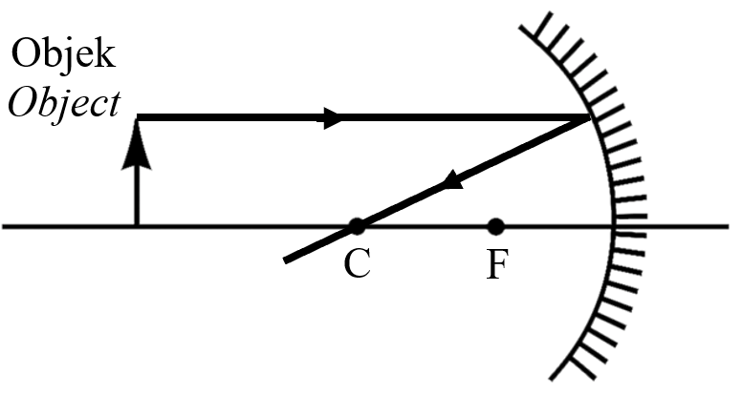
 | D | 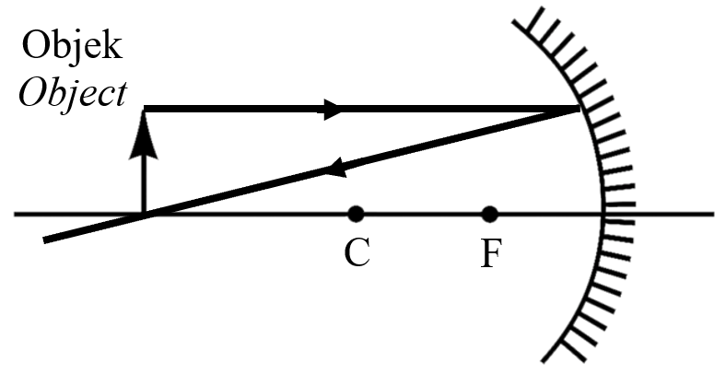

MODUL TAMAT

